Topics covered with lots of sample code and expected outputs
- Table basics
- Creating tables and printing (ordered, non-ordered, numerical and non numerical keys)
- #operator - pros and cons
- kv pairs - advantages
- Updating tables - adding adding, inserting values
- Nested Tables - printing, updating, inserting,
- Summary of key points
- Storing tables in global variables

I would have found this very useful when I started so hopefully some users will find it useful as well.
-frank & peter

Tables
A table is a tree structure, consisting of field and each field has a "key" and "value" pair.
The key can be any Lua value except nil and NaN. A table can store anything except nil.
The name of the table is the variable that stores a reference to the table so it can be accessed

Creating Tables and displaying the table data
a = {}
This is the smallest table and stores the reference to the table {} in the variable a
Consider the following table
print("table with numerical keys")
fav = {[1] = "4FM", [2] = "96FM", [3] = "Calm", [4] = "Heart", [5] = "Red_FM"}
fav is the table (or at least the name of the variable where the table is stored),
in the above table 'fav', it has 5 fields and each field consists of a key/value pair
4 is the key and 4FM is the value , 2 is a key and 96FM is the value, etc

You can display all the key/value pairs using the following ...
print("table with numerical keys and using k/v pairs to display the fields but they won't be in order")
fav = {[1] = "4FM", [2] = "96FM", [3] = "Calm", [4] = "Heart", [5] = "Red_FM"}

for k,v in pairs(fav) do print("k: " ..k..", v: "..v) end
the result is ...

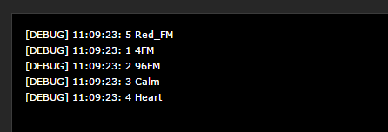

and you'll notice that the results are NOT returned in order

if you have numerical keys [1], [2] then you will need to use ipairs to return them in order
print("table with numerical keys and using k/v ipairs to display the fields in order")

fav = {[1] = "4FM", [2] = "96FM", [3] = "Calm", [4] = "Heart", [5] = "Red_FM"}

for k,v in ipairs(fav) do print("k: " ..k..", v: "..v) end

#operator
The #operator (#tablename) is used by a lot of people to identify the length of the table and use this to iterate through the table but it is not always recommended
an example of where it will work is here
print("table with numerical keys and using the #operator to iterate through the table")
radio = {"4FM", "96FM", "Calm", "Heart", "Red_FM"}

print("#operator: "..#radio)
for i = 1, #radio do print(radio[i]) end
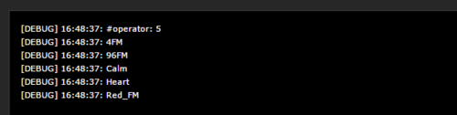

if the table keys are numerical and contiguous, it will work..
....but if they are not or you have inserted or removed values then it won't work

A good example of where it doesn't work very well is here
print("table where numerical keys are not explicitly defined but are still the table keys")
print(" example where the #operator doesnt return the correct count")
radio = {"4FM", "96FM", "Calm", "Heart", "Red_FM"}

for k,v in pairs(radio) do print("k: " ..k..", v: "..v) end
print("#operator: "..#radio)

-- remove one value, set it to nil
radio[3] = nil

for k,v in pairs(radio) do print("k: " ..k..", v: "..v) end
print("#operator: "..#radio)
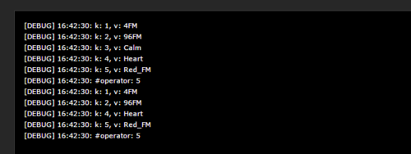
you can see that the second loop in the debug is showing an #operator value of 5 (because it is the last key but there are only 4 key/value pairs as we removed one

Another approach that is recommended to use is as follows
use the k/v approach to count the fields and then use the counter to iterate through..
print("table where numerical keys are not explicitly defined but are still the table keys")
print(" example using k/v pairs to calculate the correct table field count")

radio = {"4FM", "96FM", "Calm", "Heart", "Red_FM"}

counter = 0
for k,v in pairs(radio) do counter=counter+1 end
print("counter: "..counter)
for i = 1, counter do print(radio[i]) end

radio[3] = nil -- remove the row by setting the key to nil

counter = 0
for k,v in pairs(radio) do counter=counter+1 end
print("counter: "..counter)
for i = 1, counter do print(radio[i]) end
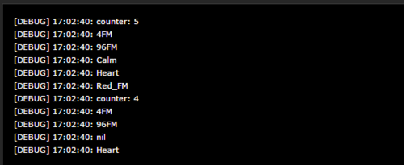

and you can see that the counter is correct in both loops

Updating Tables

you can update a table by setting Key/Value pairs or delete a value as follows
print("table where numerical keys are not explicitly defined but are still the table keys")
print("examples of updating the table")

fav = {"4FM", "96FM", "Calm", "Heart", "Red_FM"}

-- update one value add another value
fav[2] = "Soul"
fav[4] = "Classic"

-- delete value at key 1
fav[1] = nil

for k,v in pairs(fav) do print("k: " ..k..", v: "..v) end
if the k/v pair already exists it overwrites it or of the k/v pair didn't exist, it simply adds it as above
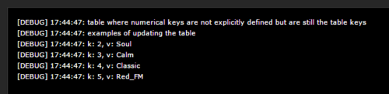

This is the same example but the table has the numerical keys explicitly defined
print("updating a table")
fav = {
[1] = "4FM",
[2] = "96FM",
[3] = "Calm",
}

fav[2] = "Soul"
fav[4] = "Classic"

for k,v in ipairs(fav) do print("k: " ..k..", v: "..v) end
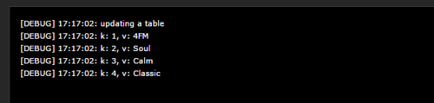

Example of adding key/value pairs to this table using table.insert
fav= {"4FM","96FM", "Soul", "Jazz"}
table.insert(fav, "Calm")
table.insert(fav, "Red_FM")
table.insert(fav, "Heart")
for k,v in pairs(fav) do print("k: " ..k..", v: "..v) end
The extra key/value pairs will be added as extra fields as you cannot specify the exact field you want to update as in the approach above
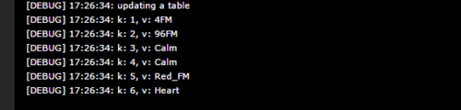

Tables with non-numerical keys are also possible as shown below
print("Table initialiser with alpha keys")
fav = {
["a"] = "4FM",
["b"] = "96FM",
["c"] = "Calm",
["d"] = "Heart",
["e"] = "Red_FM"}
for k,v in pairs(fav) do print("k: " ..k..", v: "..v) end
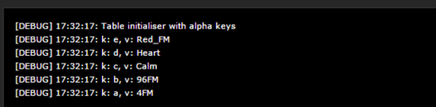

the same table can be represented in a simpler form
print("Table initialiser with alpha keys - simplified")
fav = {
a = "4FM",
b= "96FM",
c= "Calm",
d = "Heart",
e= "Red_FM"}
for k,v in pairs(fav) do print("k: " ..k..", v: "..v) end
If you chose or have to use non numerical keys or a mix, then Lua makes no guarantee on order as the spec says random.
The only way to order a table with non-numerical keys (such as alphabetical order) is to use an external reference.

Nested Tables
Lets take the following table, it looks like each value in the key/value pair is a table in itself as if one table is nested inside the other
table = {
[1] = {loc="utility_room", name="HeatingTemp"},
[2] = {loc="bed_room", name="FreezerTemp"},
}

for k,v in pairs(table) do print(k,v) end
if you run the usual k/v code you will see the second/nested set of tables
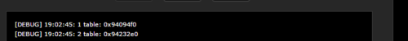

To list the k/v inside the second table you need to iterate through the first table
we use a counter like before to find out how many fields are in the outer most table
There are two tables nested within the outer most table
- table [1] which has two fields with k/v pairs
- table [2] which has two fields with k/v pairs
print("Nested table example")
table = {
[1] = {loc="utility_room", name="HeatingTemp"},
[2] = {loc="bed_room", name="FreezerTemp"},
}
for k,v in pairs(table) do
print("first level key: " ..k..", first level value: "..tostring(v))
for k2,v2 in pairs(v) do -- This works because we KNOW v is a table.
print(" second level key: " ..k2..", second level value: "..v2)
end
end
we then use the counter to expose the k/v pairs at table[1] and table [2] with the following result

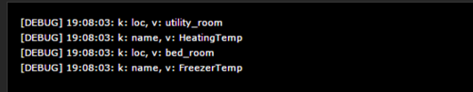

You could also expose specific values (in the nested able) using the following
table = {
[1] = {loc="utility_room", name="HeatingTemp"},
[2] = {loc="bed_room", name="FreezerTemp"},
}

for k,v in pairs(table) do

print("location: "..table[k].loc)

end
with the following expected result
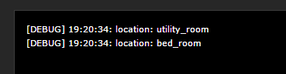

You could also have used the #operator that we discussed earlier BUT only because the key's in the outer-most table are numerical and contingous
for i = 1, #table do -- #list refers to the max number of items in the table

fibaro:debug(table[i].ip, table[i].port)

end

Updating a value in a nested table

If you want to update a specific value in the nested table you need to use the k/v method we have discussed
fav = {
[1] = {loc="utility_room", name="HeatingTemp"},
[2] = {loc="bed_room", name="FreezerTemp"},
}

-- update nested table on the second field with a new value
fav[2].loc = "kitchen"
fav[2].name = "Hobtemp"

-- or you could use the following format to do accomplish the same update
fav[2]["loc"] = "kitchen"
fav[2]["name"] = "Hobtemp"

-- print out the updated table...

for k,v in pairs(fav) do

for k,v in pairs(fav[k]) do print("k: " ..k..", v: "..v) end

end

-- second option to print out the updated table with more explanation
for k,v in pairs(fav) do
print("first level key: " ..k..", first level value: "..tostring(v))
for k2,v2 in pairs(v) do -- This works because we KNOW v is a table.
print(" second level key: " ..k2..", second level value: "..v2)
end
end
the result is
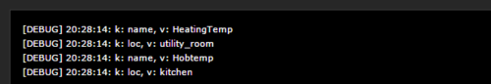

If you want to add/insert a new k/v pair in the nested level, you can use the table.insert method
fav = {
[1] = {loc="utility_room", name="HeatingTemp"},
[2] = {loc="bed_room", name="FreezerTemp"},
}

-- insert a new value
table.insert(fav,{loc="bedroom", name="sinktemp"})

-- print out the updated table...
for k,v in pairs(fav) do

for k,v in pairs(fav[k]) do print("k: " ..k..", v: "..v) end

end

-- second option to print out the updated table with more explanation
for k,v in pairs(fav) do
print("first level key: " ..k..", first level value: "..tostring(v))
for k2,v2 in pairs(v) do -- This works because we KNOW v is a table.
print(" second level key: " ..k2..", second level value: "..v2)
end
end
and the result is three fields in the table
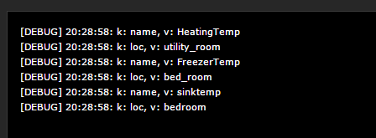

So before we go to the last task of storing the table in a global variable, I thought it would be good to have a quick recap..

Summary
A table is a tree structure, consisting of field and each field has a "key" and "value" pair.
The name of the table is the variable that stores a reference to the table so it can be accessed
you can explicitly declare a numerical key in a table but you don't have to
- for a table with a numerical key - use ipairs to print the table fields in order
- #operator can be used but ONLY for tables with numerical keys that are contiguous
- it is recommended to use the standard k/v approach to count the number of fields
- remove a value by setting its key = nil
- update a table using the table[key] method
- add a new field using table.insert(table, "value") and will add a numerical key
- table.insert will not work with tables with non-numerical keys
- tables with non-numerical keys cannot be printed in order by ipairs, result will be random
- nested tables require iteration to print the inner-most tables
- multiple levels of iteration required for multi-nested tables
- updating nested table - iterate with k/v and use table[key].nested-key = "value"
- inserting into nested table - iterate with k/v and use table.insert(table,{key="value, key="value}
- tables can be very confusing and frustrating to us newbie's , so take your time

Storing a table in a global variable
if you take the following table structure
Table = {
group = {
option1=1560,option2=1507,option3=881
},
}

If you want to store this table in a global variable you will need to encode the table as a string. One of the most common formats to encode a table (structure) is json

from json.org
"JSON (JavaScript Object Notation) is a lightweight data-interchange format. It is easy for humans to read and write. It is easy for machines to parse and generate."

To save the table you need to encode it and then save it to the global variable
jTable = json.encode(table)
fibaro:setGlobal("StateTable", jTable)

In order to read back a single value you need to decode the string
local jT = json.decode(fibaro:getGlobalValue("Table"))
once it's decoded you can then read one of the values or manipulate the table
fibaro:debug(jT.group.option1)

Updating a single value
- assign the new value, encode it and the store it.....
jT.group.option3 = 987
jTable = json.encode(jT)
fibaro:setGlobal("StateTable", jTable)

Making json strings/output easier to read...
Sometimes a json string can be difficult to read and understand its structure. Typically they would look something like this...
{"widget": {"debug": "on","window": {"title": "Sample Konfabulator Widget","name": "main_window","width": 500,"height": 500},"image": {"src": "Images/Sun.png","name": "sun1","hOffset": 250, "vOffset": 250,"alignment": "center"},"text": {"data": "Click Here","size": 36,"style": "bold","name": "text1","hOffset": 250,"vOffset": 100,"alignment": "center","onMouseUp": "sun1.opacity = (sun1.opacity / 100) * 90;"}}}
There are a number of websites that will 'pretify' the string make it easier to read the structure and enable you to understand how you might navigate it.
If you take json string above and paste it into http://jsonprettyprint.com/ it will display it more like a table
This format is easier to understand

{
"widget": {
"debug": "on",
"window": {
"title": "Sample Konfabulator Widget",
"name": "main_window",
"width": 500,
"height": 500
},
"image": {
"src": "Images\/Sun.png",
"name": "sun1",
"hOffset": 250,
"vOffset": 250,
"alignment": "center"
},
"text": {
"data": "Click Here",
"size": 36,
"style": "bold",
"name": "text1",
"hOffset": 250,
"vOffset": 100,
"alignment": "center",
"onMouseUp": "sun1.opacity = (sun1.opacity \/ 100) * 90;"
}
}
}

Finally....
There is a very good discussion on using a table in a predefined variables to store the ID's of scenes and devices for the HC2
- https://forum.fibaro.com/index.php?/topic/23942-tutorial-using-a-hometable-to-store-device-and-scene-ids/
suggestions to improve welcome
-f

Edited February 22, 2017 by AutoFrank
--main loop
local jT = json.decode(fibaro:getGlobalValue("HomeTable"))

local device = fibaro:getSelfId();
local zonename = fibaro:getName(device);
local ipaddress = fibaro:getValue(device, "IPAddress");
local port = fibaro:getValue(device, "TCPPort");
sonos = Net.FHttp(ipaddress, port);

response = sonos:GET("/kitchen/state");
jsonTable = json.decode(response);

fibaro:debug(jsonTable.volume)

fibaro:call(device,"setProperty","ui.status.value", jsonTable.playbackState);
fibaro:call(device,"setProperty","ui.volume.value", jsonTable.volume);
fibaro:call(device,"setProperty","ui.nowplaying.value", jsonTable.currentTrack.title);
fibaro:log(jsonTable.playbackState)
and vd setup is the ip address of the player and the port which I think is 1400.
Autofrank.....looks like your last bit of code worked although I had to remove the first line as it doesn't seem relevant to my system.
Oops ...sorry about that
I used a table (HomeTable) to manage all my device id's

I use this api extensively and if you like I can send on some examples later …

- 
- 
- 
- 321
- 2,331 posts
- Ireland
- Gateway/s: Home Center 2
- Report post

Posted October 4, 2017
Hi
Re-coded my Sonos status VD into a more generic table based VD

This VD monitorsd and displays status of Sonos devices (OFFLINE, STATE (PLAYING, STOPPED, ETC & VOLUME)
Notification options for when a player goes offline and back online and is configurable (Smart Message Hub or HC2 email)
One Alert will be received when player goes offline and another when it comes back online
Online/Offline status is captured in global table (SonosTable) that can be used by other scenes and VD's
** YOU NEED TO BE USING THE SONOS-HTTP-API FOR THIS VD **
** YOU NEED TO BE USING THE WWWAPI MONITOR FOR THIS VD **
https://musicpartners.sonos.com/?q=home&destination=node%2F23
https://developer.sonos.com/reference/authorization-api/
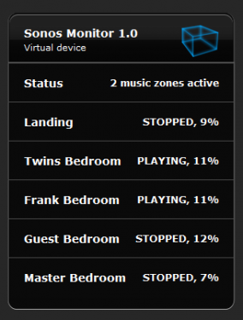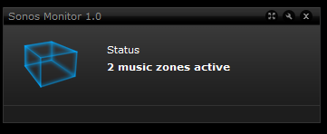

==INSTALLATION STEPS ==
- Import the Sonos Monitor 1.0 virtual device, add IP and Port of sonos API on VD General Tab
- Status heading and one sonos player label (Label1) has been created as part of the VD
- it will created a global variabnle called SonosTable
- Add one label per extra sonos players you have using the default label naming (Lable2, Lable3, Label4, etc)
- Populate the sonos table with Player (what player is called in sonos) and Room (room name in HC2)
- Run VD with updateData = "true" to populate the device table. Open debug window and you shold see
- "Sonos Table successfully Updated" followed by which sonos players are online

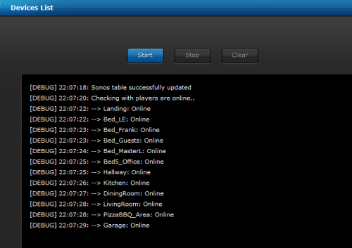

- Run VD with updateData = "false" to operate in normal mode
- Enable Debug = true to see status in debug window
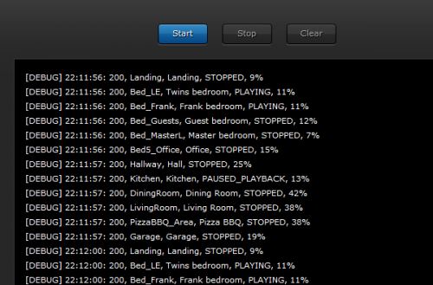

VD attached below

Suggested icon


